Please wear this safety pin in a visible place (like near your collar or lapel) as a sign that you are an ally and a “safe” person to our neighbors who are immigrants, women, LGBTQIA+, wearing hijab, disabled, PoC, etc.. The safety pin is a visual sign to people scapegoated during this election they can feel safe sitting with you on the bus, in line at the store, or wherever. Any safety pin will work, but here's one to wear today! This movement started in Britain to fight anti-immigrant backlash and is now rapidly making its way here. Let’s do this!  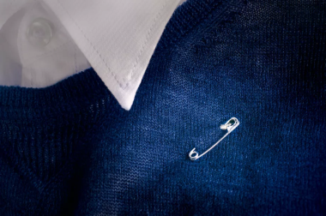 |  | Please wear this safety pin in a visible place (like near your collar or lapel) as a sign that you are an ally and a “safe” person to our neighbors who are immigrants, women, LGBTQIA+, wearing hijab, disabled, PoC, etc.. The safety pin is a visual sign to marginalized people scapegoated during this election they can feel safe sitting with you on the bus, in line at the store, or wherever. Any safety pin will work, but here's one to wear today! This movement started in Britain to fight anti-immigrant backlash and is now rapidly making its way here. Let’s do this!
Please wear this safety pin in a visible place (like near your collar or lapel) as a sign that you are an ally and a “safe” person to our neighbors who are immigrants, women, LGBTQIA+, wearing hijab, disabled, PoC, etc.. The safety pin is a visual sign to marginalized people scapegoated during this election they can feel safe sitting with you on the bus, in line at the store, or wherever. Any safety pin will work, but here's one to wear today! This movement started in Britain to fight anti-immigrant backlash and is now rapidly making its way here. Let’s do this!  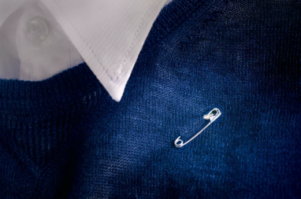 |  | Please wear this safety pin in a visible place (like near your collar or lapel) as a sign that you are an ally and a “safe” person to our neighbors who are immigrants, women, LGBTQIA+, wearing hijab, disabled, PoC, etc.. The safety pin is a visual sign to marginalized people scapegoated during this election they can feel safe sitting with you on the bus, in line at the store, or wherever. Any safety pin will work, but here's one to wear today! This movement started in Britain to fight anti-immigrant backlash and is now rapidly making its way here. Let’s do this!
Please wear this safety pin in a visible place (like near your collar or lapel) as a sign that you are an ally and a “safe” person to our neighbors who are immigrants, women, LGBTQIA+, wearing hijab, disabled, PoC, etc.. The safety pin is a visual sign to marginalized people scapegoated during this election they can feel safe sitting with you on the bus, in line at the store, or wherever. Any safety pin will work, but here's one to wear today! This movement started in Britain to fight anti-immigrant backlash and is now rapidly making its way here. Let’s do this!  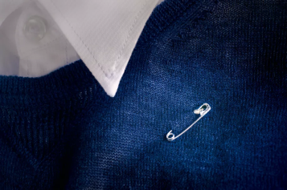 |  | Please wear this safety pin in a visible place (like near your collar or lapel) as a sign that you are an ally and a “safe” person to our neighbors who are immigrants, women, LGBTQIA+, wearing hijab, disabled, PoC, etc.. The safety pin is a visual sign to marginalized people scapegoated during this election they can feel safe sitting with you on the bus, in line at the store, or wherever. Any safety pin will work, but here's one to wear today! This movement started in Britain to fight anti-immigrant backlash and is now rapidly making its way here. Let’s do this!

